**Activity 1:**

Redis docker image:

Docker container :  
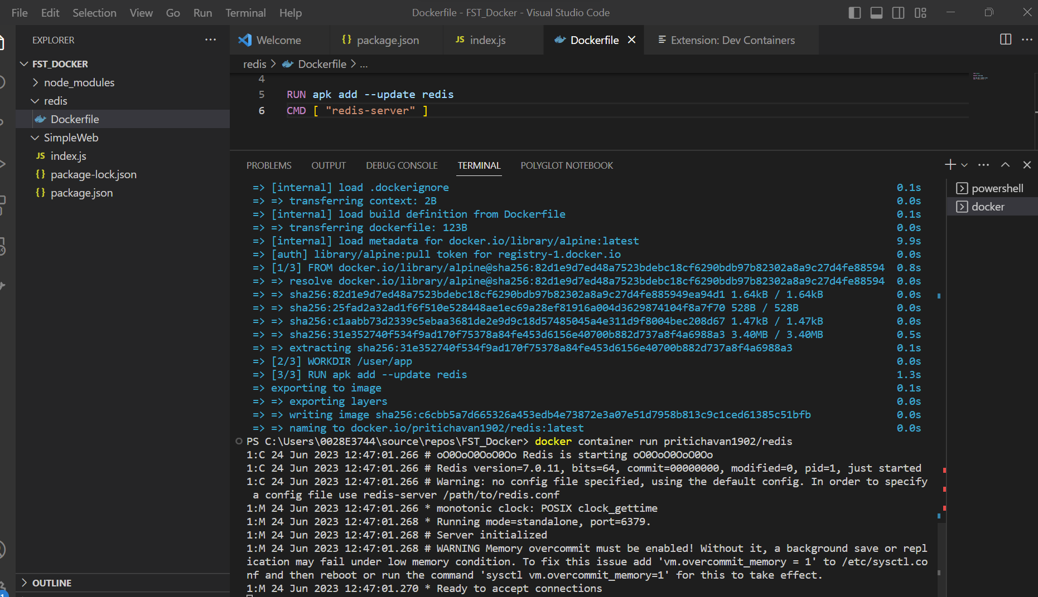

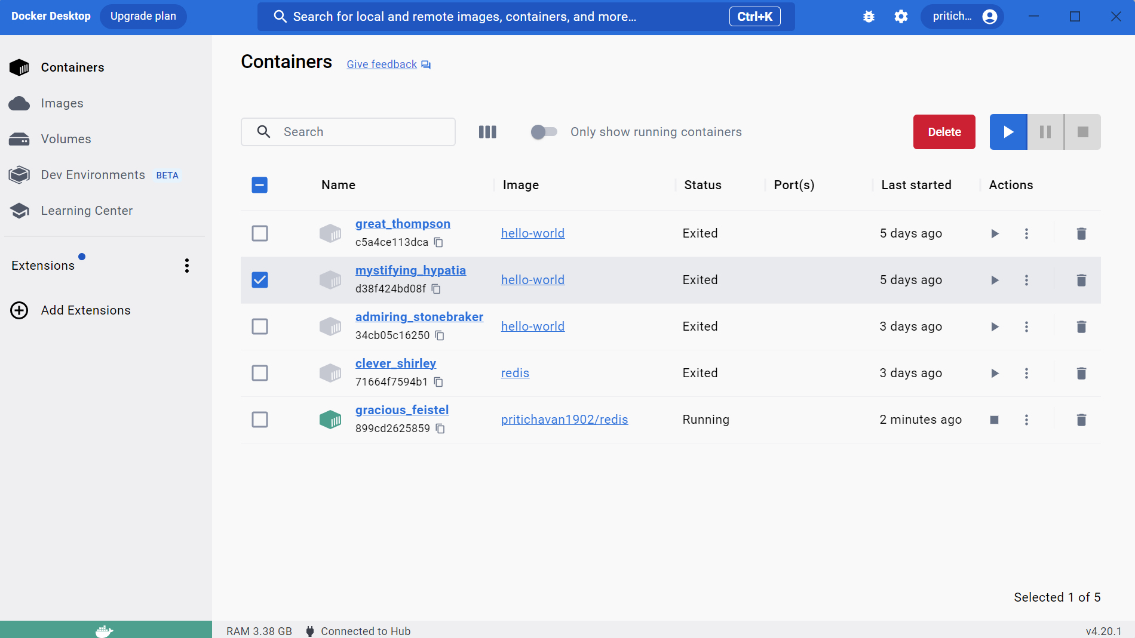

Docker image push :

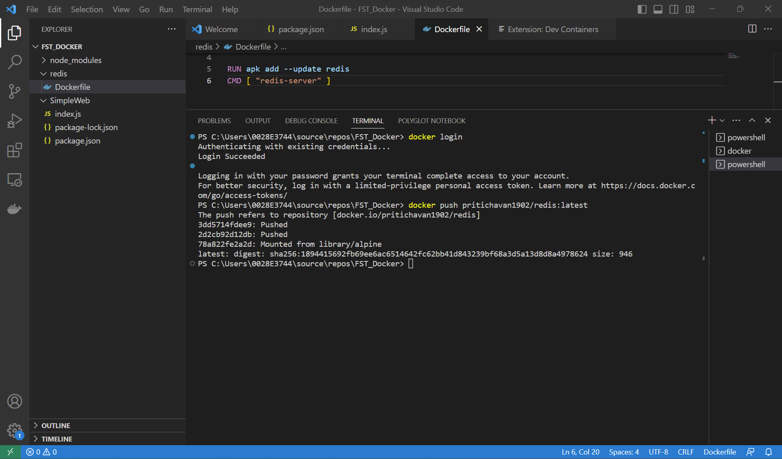

Dockerfile first mistake :

Fixed 1st issue:

2nd issue:

Fixed 2nd issue :

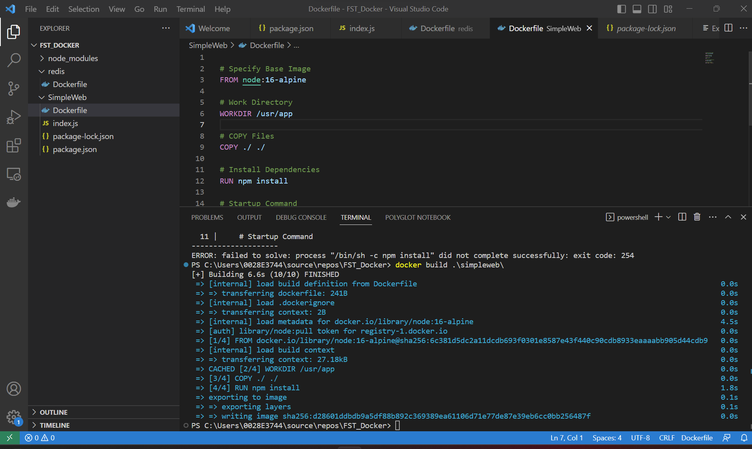

**Containerizing a Real Application with Docker :**

Creating docker image :

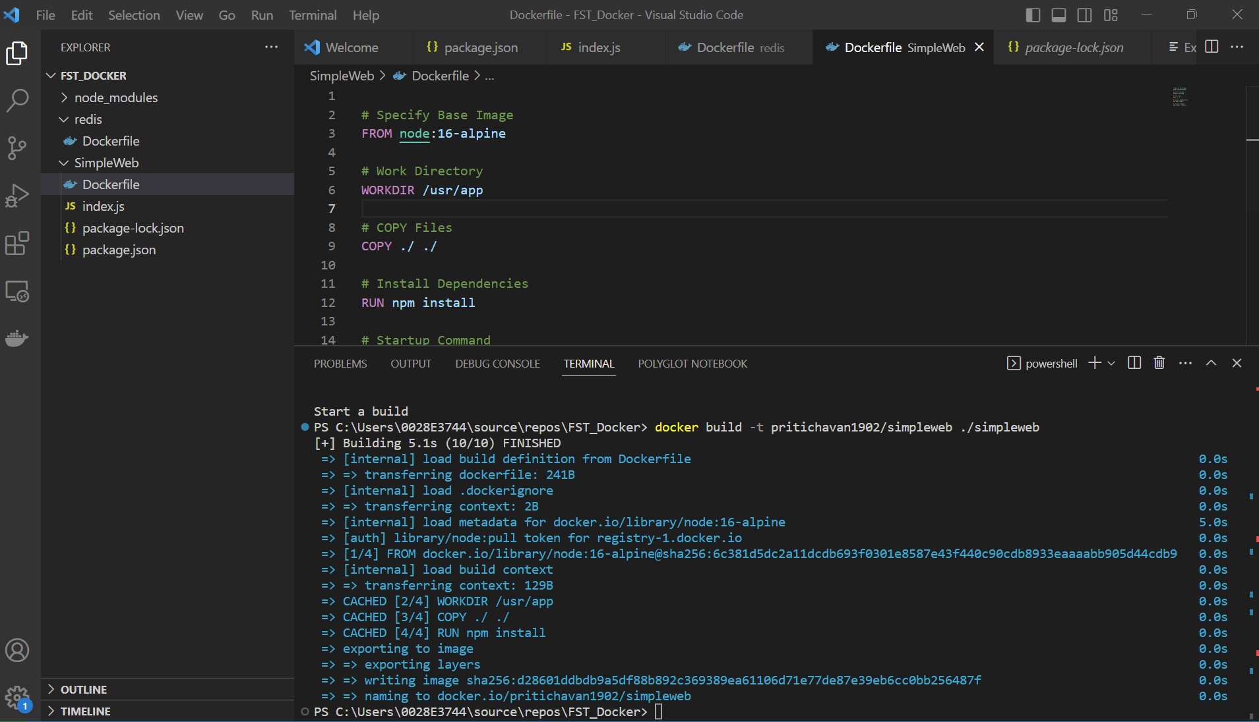

Running the application:

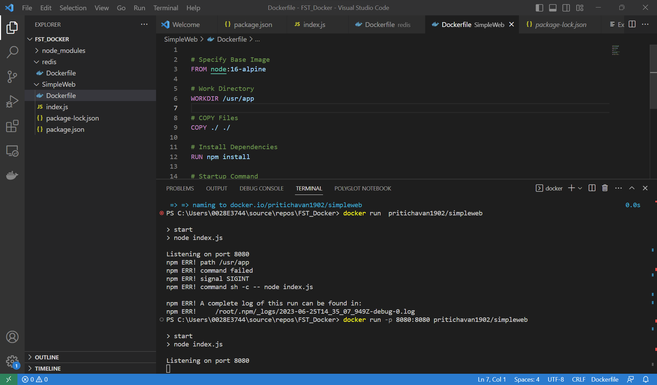

Push SimpleWeb to docker hub :

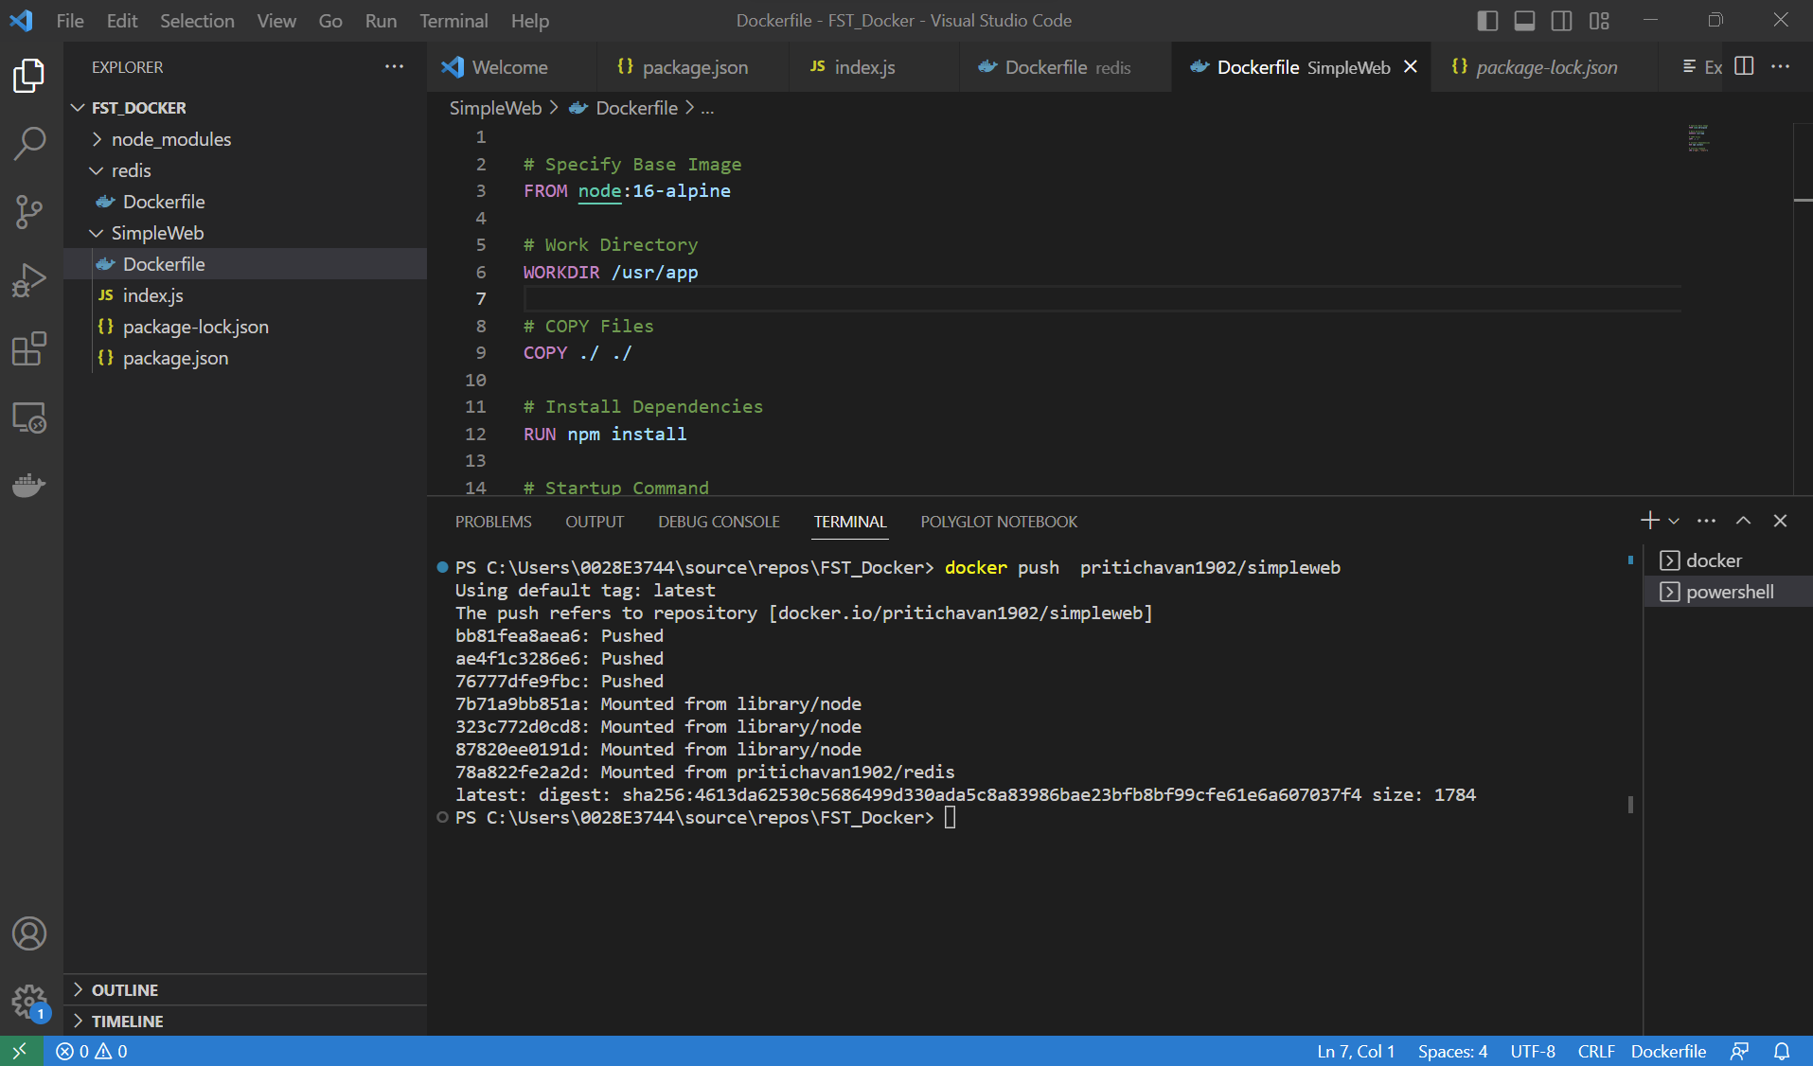

Creating Visits app image :

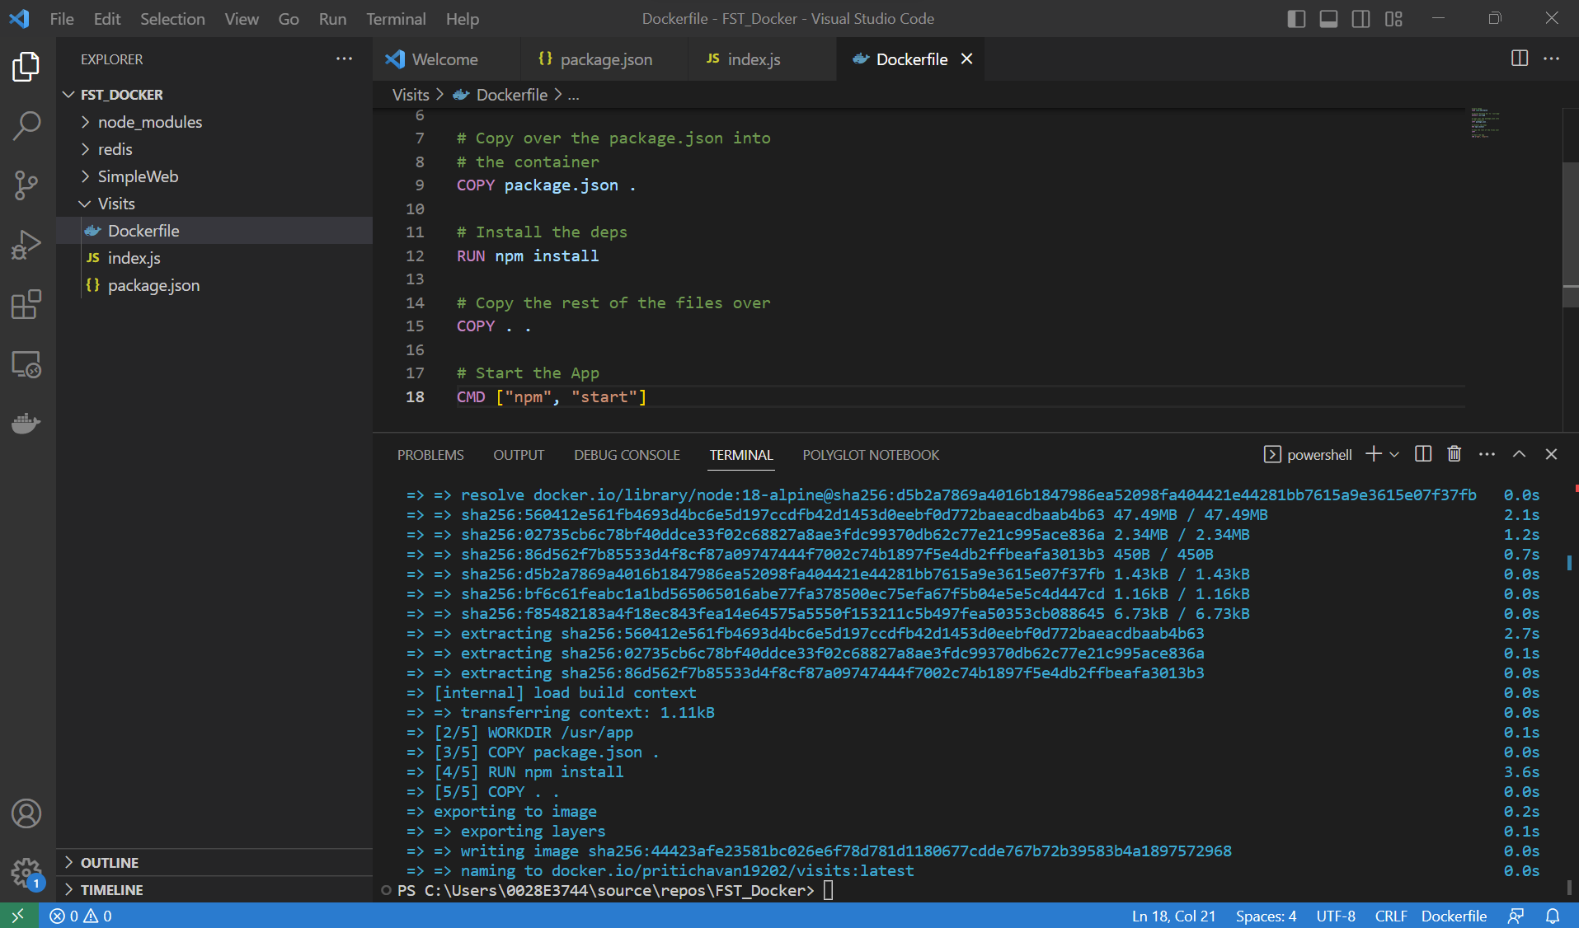

Docker compose :

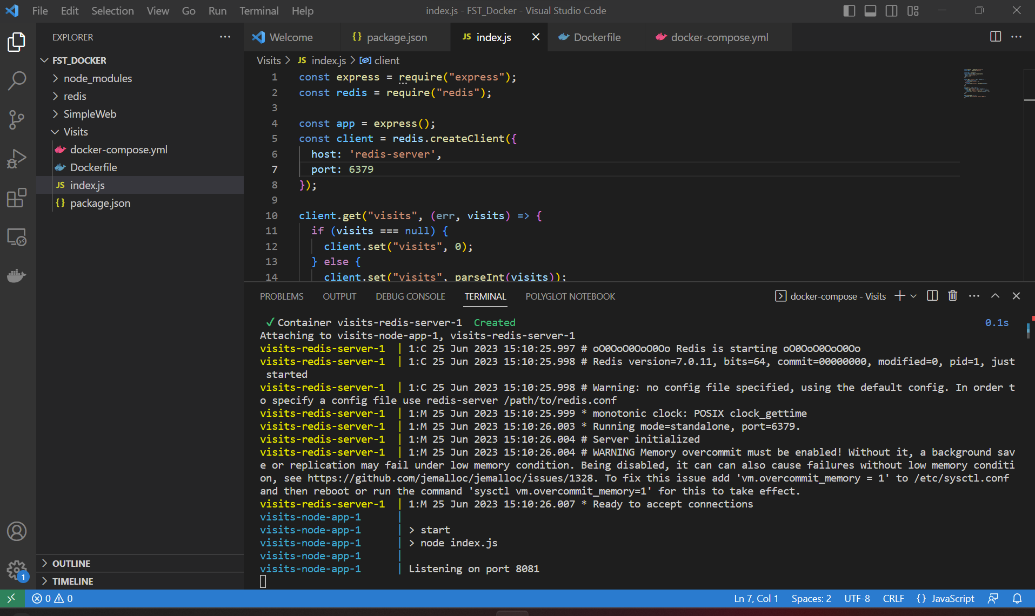

Hitting app multiple times and seeing if visit count is updated :

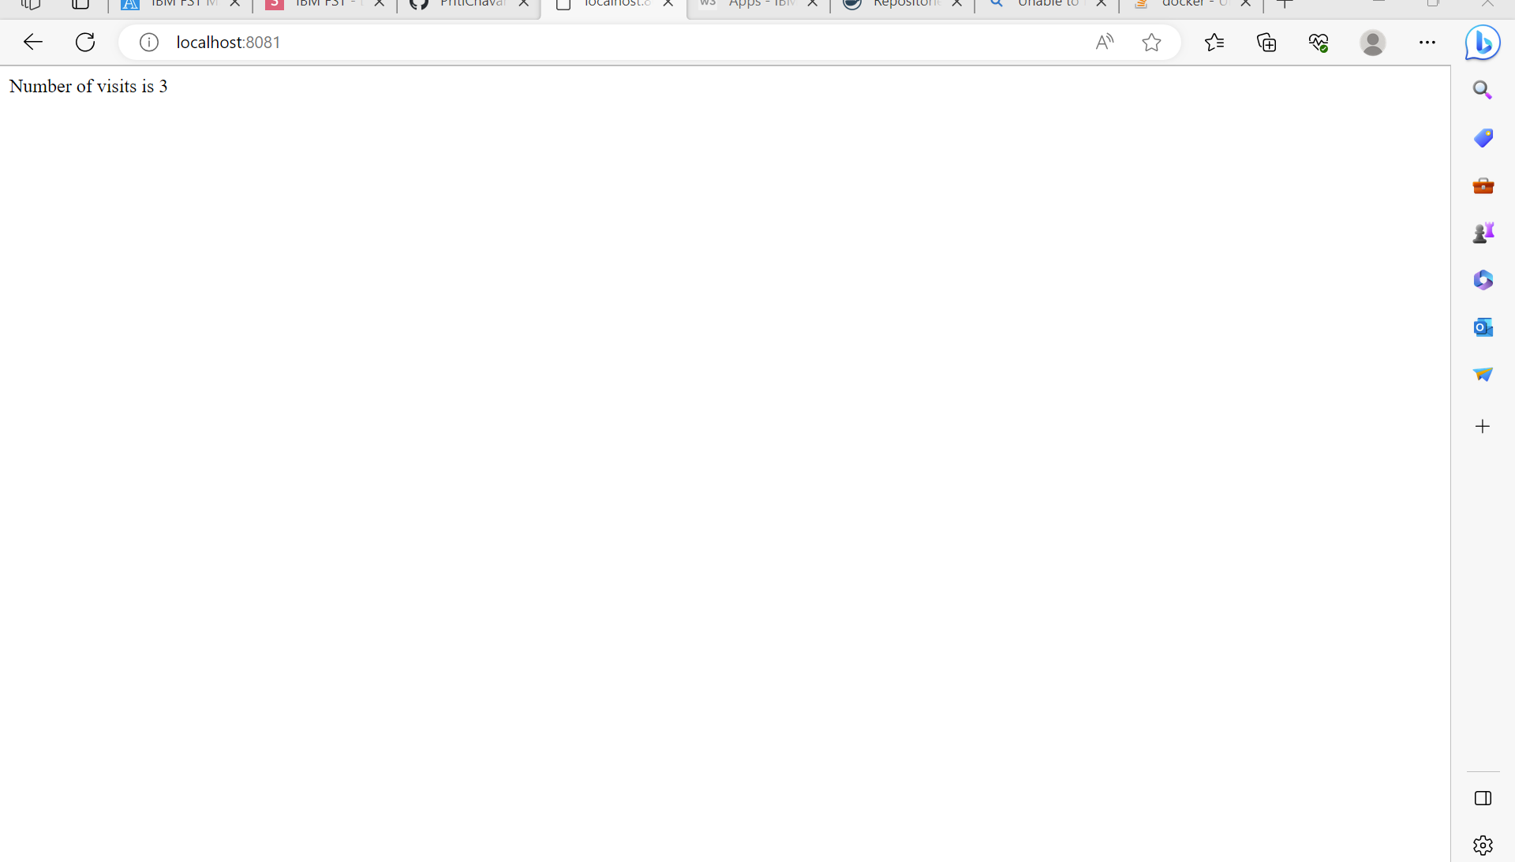

**Activity 2: Containerizing a Complex Application**

Updated values after few hits to the application:  
